Introduction to the Breadboard, Wiring, and 7400 Logic Chips
(Final Report)

Ho, Hingkei SID: 103 079 575
Vega, Roberto Javier SID: 003 110 717
CS152A / EE116L
LAB 1, Sec 4 T.A. Wendong, Hu
Introduction:

The lab was an introductory experiment to learn how to use the components and equipment used throughout the term. The components can be divided in three categories:

- The Breadboard, which is a test laboratory board in where all of the circuitry are constructed, and tested.

- The 74xx Logic Chips, which provides pre-assembled building block for the circuits (AND, NAND, OR, XOR and other types of elements).

- The Clean Clock, which provides clean signals for building digitals circuits.

Design Description:

The first part of the laboratory was to simulate an OR gate using a 7432 chip. First we putted the chip into the ProtoBoard with the dot facing down so that the 1 connector was on the bottom right and the 14th connector was on the bottom left. Then we connected the voltage and the ground connectors to the appropriate pins. Two input switches from the Altera board were wired to connectors in parallel with the 12th and 13th pins and the 11th pin was wired to one of the LED lights as an output. Next, we powered on and then filled out the output of the truth table by switching the input switches and recording the resulting table:

OR gate
IN-1 | IN-2 | OUT-3
0 | 0 | 0
0 | 1 | 1
1 | 0 | 1
0 | 1 | 1

The second part of the experiment was to use the 7400 chips to simulate an NAND gate. We putted the chip into the ProtoBoard and we wired inputs to the 13th and 12th pin, output to the 11th pin, Voltage source to the 14th pin, and ground to the 7th pin of the chip. Then powered on the circuit and recorded the results in the following table:

NAND gate
IN-1 | IN-2 | OUT-3
0 | 0 | 1
0 | 1 | 1
1 | 0 | 1
0 | 1 | 0

The third part of the laboratory involved two XOR gates and three NAND gates. We used one 7486 chip for the two XOR gates and one 7400 chips for the three NAND gates. The inputs to the left XOR gate were wired to pins 13 and 12. The XOR and NAND gates where wired to accomplish the desire circuit and the desire output. The output of the second XOR was labeled RES and came from the 8th pin of the 7486 chip. The output of the second NAND gate came from pin 8th of the chip and we wired it to input one of the third NAND gate in pin 4 of the 7400 chip. The output from the first NAND gate came from pin 11 of the chip and was wired to the second input of the third NAND gate in pin 5. The output of that NAND came from
pin 6 and was wired to another LED to represent CARRY. The results were recorded in the following table:

INPUTS |  |  | OUTPUTS
A | B | C | RES | CARRY
0 | 0 | 0 | 0 | 0
0 | 0 | 1 | 1 | 0
0 | 1 | 0 | 1 | 0
0 | 1 | 1 | 0 | 1
1 | 0 | 0 | 1 | 0
1 | 0 | 1 | 0 | 1
1 | 1 | 0 | 0 | 1
1 | 1 | 1 | 1 | 1

The fourth part of the laboratory involved a 7474 chip configured as a D-Flip-Flop. The circuit was wired up and attached the Q output to a LED. Then we tested the actions of the PRESET and CLEAR inputs of the D-Flip-Flop. The output of the Flip Flop changes with respect to the edge of the rising clock cycle only. No changes happened if the clock jumps from LOW to HIGH. New Data was obtained at the rising of the edge clock in the 7474. Indeed, it can be concluded that the D flip-flop is a leading edge memory cell.

The fifths part of experiment involved creating two versions of a machine capable of detecting changes in the input signal. The inputted was stored the in the D Flip-Flop, and XOR the MOOD at (t-1) with MOOD at (t), therefore observing if MOOD has changed since the last clock. Because the output is dependant on the input, this is a Mealy machine.

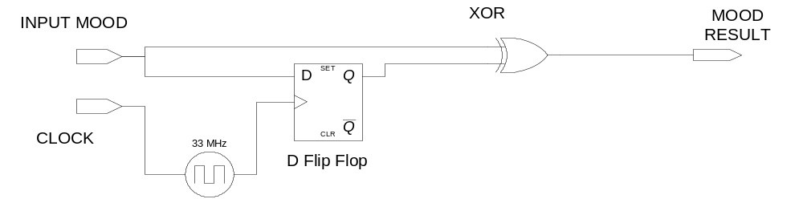

A Moore machine design needs to have another set of memory cell to store MOOD at (t-2). Because MOOD at (t-2) as well as MOOD (t-1) are stored in the flip-flops and are not directly dependent from the input, the design represents a Moore machine.

